Bank Loan Project
Bank Loan Project Quary Summary
KPI’s
select count(id) as Total_Loan_Applications from Bank_Loan_Data
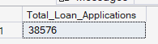

select count(id) as MTD_Total_Loan_Applications from Bank_Loan_Data
where MONTH(issue_date) = 12 AND YEAR(issue_date) = 2021
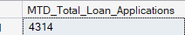

select count(id) as PMTD_Total_Loan_Applications from Bank_Loan_Data
where MONTH(issue_date) = 11 AND YEAR(issue_date) = 2021
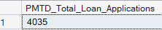

select SUM(loan_amount) as Total_Funded_Amount from Bank_Loan_Data
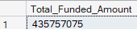

select SUM(loan_amount) as MTD_Total_Funded_Amount from Bank_Loan_Data
where MONTH(issue_date) = 12 AND YEAR(issue_date) = 2021
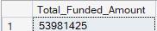

select SUM(loan_amount) as PMTD_Total_Funded_Amount from Bank_Loan_Data
where MONTH(issue_date) = 11 AND YEAR(issue_date) = 2021
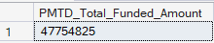

select SUM(total_payment) as Total_Payment_Received from Bank_Loan_Data
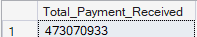

select SUM(total_payment) as MTD_Total_Payment_Received from Bank_Loan_Data
where MONTH(issue_date) = 12 AND YEAR(issue_date) = 2021
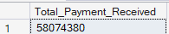

select SUM(total_payment) as PMTD_Total_Payment_Received from Bank_Loan_Data
where MONTH(issue_date) = 11 AND YEAR(issue_date) = 2021
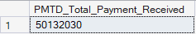

select avg(int_rate) as Avg_Interest_Rate from Bank_Loan_Data
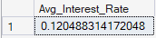

select avg(int_rate)* 100 as MTD_Avg_Interest_Rate from Bank_Loan_Data
where MONTH(issue_date) = 12 AND YEAR(issue_date) = 2021
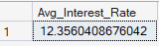

select avg(int_rate)* 100 as MTD_Avg_Interest_Rate from Bank_Loan_Data
where MONTH(issue_date) = 11 AND YEAR(issue_date) = 2021
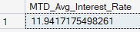

select avg(dti)* 100 as MTD_Avg_DTI_Rate from Bank_Loan_Data
where MONTH(issue_date) = 12 AND YEAR(issue_date) = 2021
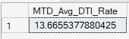

select avg(dti)* 100 as PMTD_Avg_DTI_Rate from Bank_Loan_Data
where MONTH(issue_date) = 11 AND YEAR(issue_date) = 2021
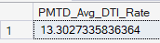

Select
(count(case when loan_status = 'Fully Paid' or loan_status = 'Current' then id END )*100)
/
count(id) as Good_loan_percentage
from Bank_Loan_Data
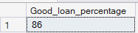

Select count(id) as Good_Loan_Applications from Bank_Loan_Data
where loan_status = 'Fully Paid' or loan_status = 'Current'
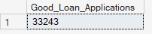

Select sum(loan_amount) as Good_Loan_Funded_Amount from Bank_Loan_Data
where loan_status = 'Fully Paid' or loan_status = 'Current'
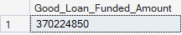

Select sum(total_payment) as Good_Loan_Receeived_Amount from Bank_Loan_Data
where loan_status = 'Fully Paid' or loan_status = 'Current'
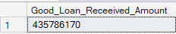

SELECT
(SUM(CASE WHEN loan_status = 'Charged Off' THEN 1 ELSE 0 END) * 100.0) /
COUNT(id) AS Bad_Loan_Percentage
FROM Bank_Loan_Data;
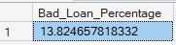

Select count(id) as Bad_Loan_Applications from Bank_Loan_Data
where loan_status = 'Charged Off'
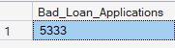

Select sum(loan_amount) as Bad_Loan_Funded_Amount from Bank_Loan_Data
where loan_status = 'Charged Off'
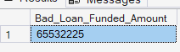

Select sum(total_payment) as Bad_Loan_Received_Amount from Bank_Loan_Data
where loan_status = 'Charged Off'
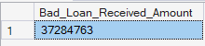

select
loan_status,
count(id) as Total_Loan_Applications,
sum(total_payment) as Total_Amount_Received,
sum(loan_amount) as Total_Funded_Amount,
Avg(int_rate * 100) as Interest_Rate ,
avg(dti*100) As DTI
From
Bank_Loan_Data
Group by
loan_status

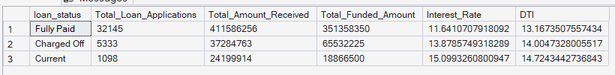

select
loan_status,
SUM(total_payment) as MTD_Total_Payment_Received,
SUM(loan_amount) as MTD_Total_Funded_Amount
From Bank_Loan_Data
where MONTH(issue_date) = 12
Group by loan_status
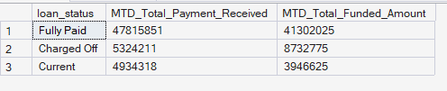

Select
MONTH(issue_date) as Month_Number,
Datename(month, issue_date) as Month_Name,
count(id) as Total_Loan_Applications,
sum(loan_amount) as Total_Funded_Amount,
sum(total_payment) as Total_Received_Amount
From Bank_Loan_Data
Group by MONTH(issue_date),Datename(month, issue_date)
order by MONTH(issue_date)
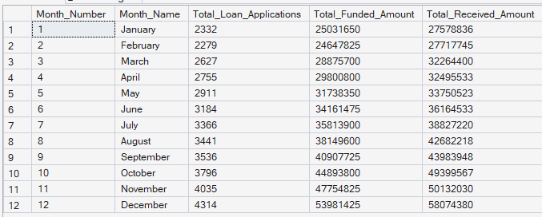

Select
address_state,
count(id) as Total_Loan_Applications,
sum(loan_amount) as Total_Funded_Amount,
sum(total_payment) as Total_Received_Amount
From Bank_Loan_Data
Group by address_state
order by address_state
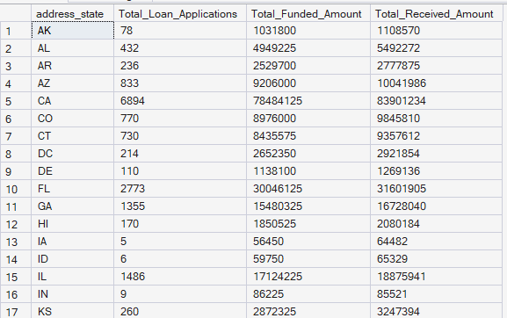

Select
term,
count(id) as Total_Loan_Applications,
sum(loan_amount) as Total_Funded_Amount,
sum(total_payment) as Total_Received_Amount
From Bank_Loan_Data
Group by term
order by term
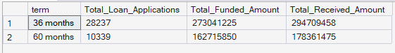

Select
emp_length,
count(id) as Total_Loan_Applications,
sum(loan_amount) as Total_Funded_Amount,
sum(total_payment) as Total_Received_Amount
From Bank_Loan_Data
Group by emp_length
order by emp_length
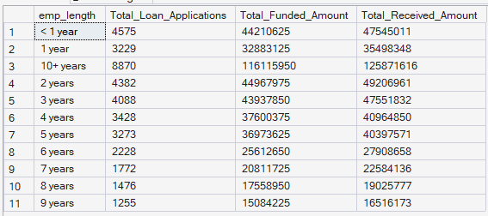

Select
purpose,
count(id) as Total_Loan_Applications,
sum(loan_amount) as Total_Funded_Amount,
sum(total_payment) as Total_Received_Amount
From Bank_Loan_Data
Group by purpose
order by purpose
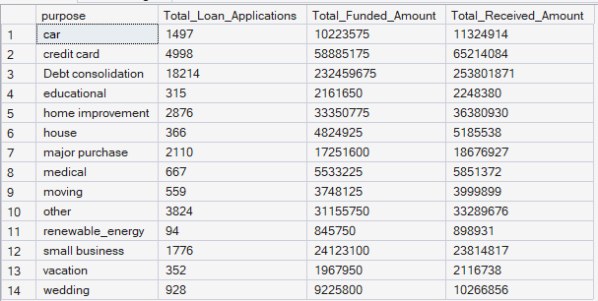
Select
home_ownership,
count(id) as Total_Loan_Applications,
sum(loan_amount) as Total_Funded_Amount,
sum(total_payment) as Total_Received_Amount
From Bank_Loan_Data
Group by home_ownership
order by home_ownership
